Creating an Inferred Target Group

During the creation of a targeted or normalized sample, you may find that you wish to target based on groupings of values instead of individual values. For example, you may wish to target based on custom defined age ranges or you may wish to target based on party, grouping certain unaffiliated/independent party codes together into one group for example.

To do this, you need to create an inferred target group. Click on the Inferred Target Group button:
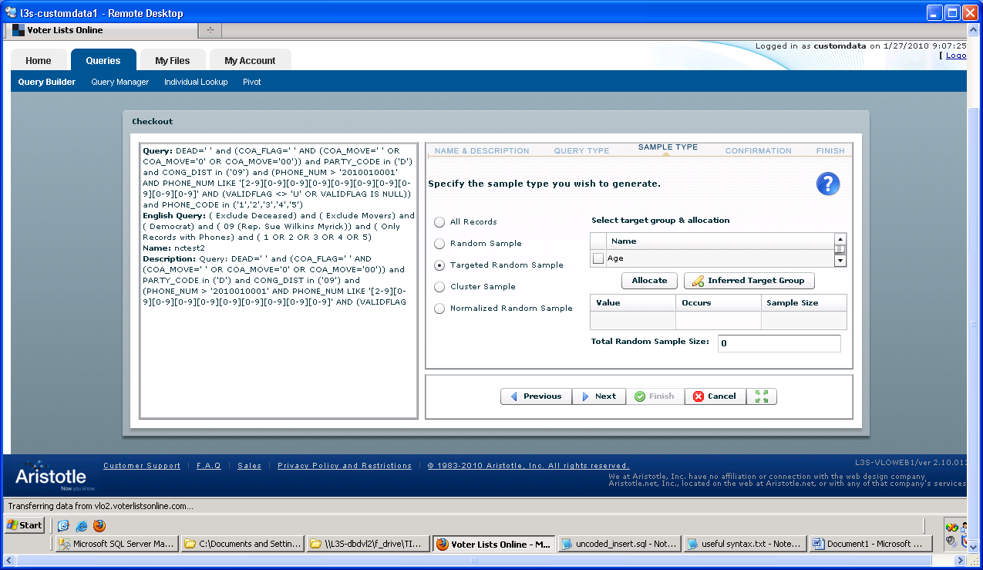

Click “New” at the bottom of the inferred target group window to begin the process of defining your inferred target group. The Base Column is where you specify which existing field you are basing your inferred target on. For example, Age, Party Code, etc. The next several fields (Expression, Field Name, Description, Help) can be left with the default values or modified as desired:

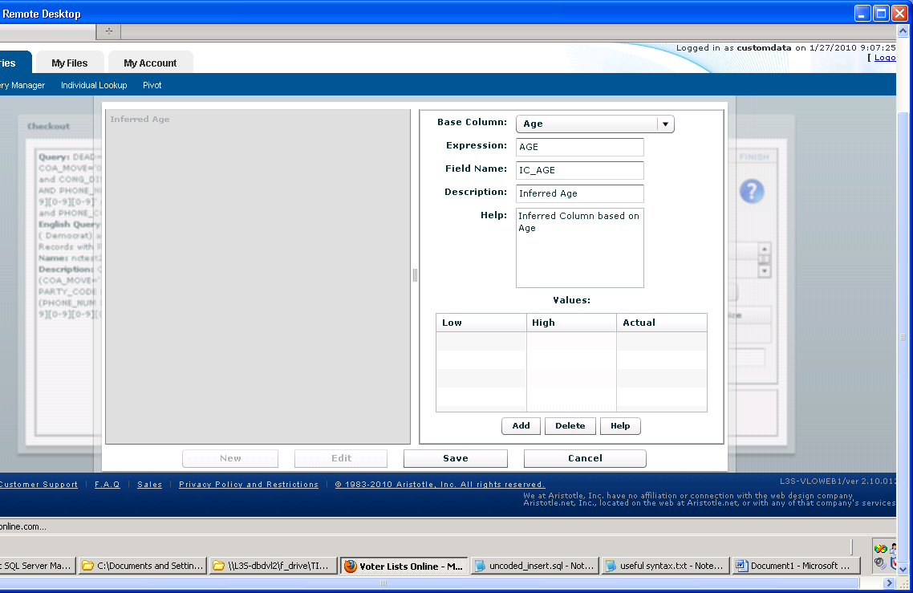

Next, you need to define the Values you wish to use in your inferred target group. Let’s use the example of Age first. Click the Add button below the Values box. In the Low column, you would specify the Low end of the age range you are defining, and in the High column you would specify the high value. The Actual column will contain a name that you choose to call this newly created value. Continue to add each value until you have them all defined. For example:
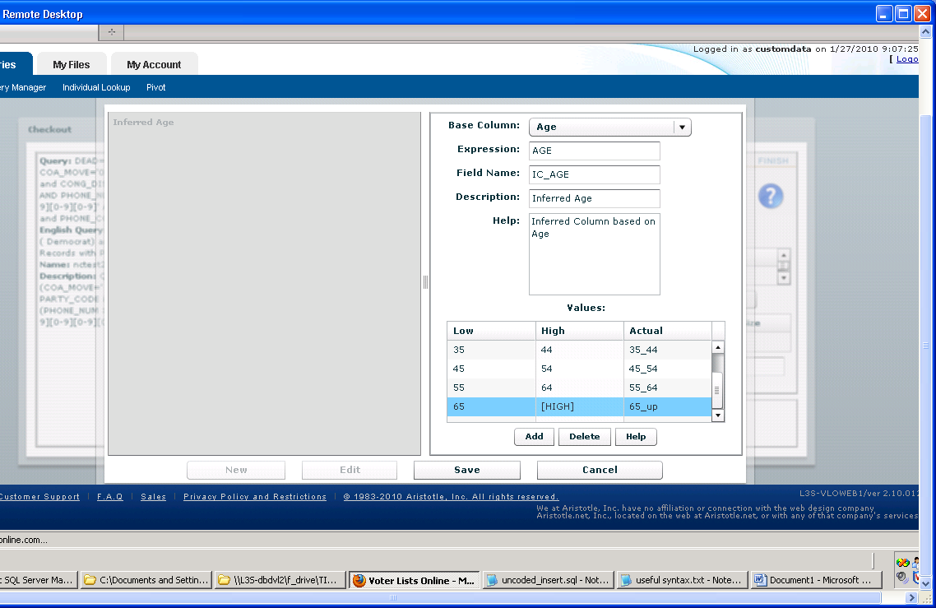
By leaving the “High” column blank for the 65_up age group, it will include all values greater than 65 in this group. If you wanted all values lower than a certain value, say 24 and under, you would specify 24 in the high column and leave the low column blank. Once you have your age bands defined, click Save and close the window. Now, if you scroll to the bottom of the “select target group & allocation” list, you will see your inferred age column listed in red. Select it and choose Allocate. After the results are displayed, you will be able to see the number of records falling into each inferred age category and enter the number per each that you wish to include in your sample:
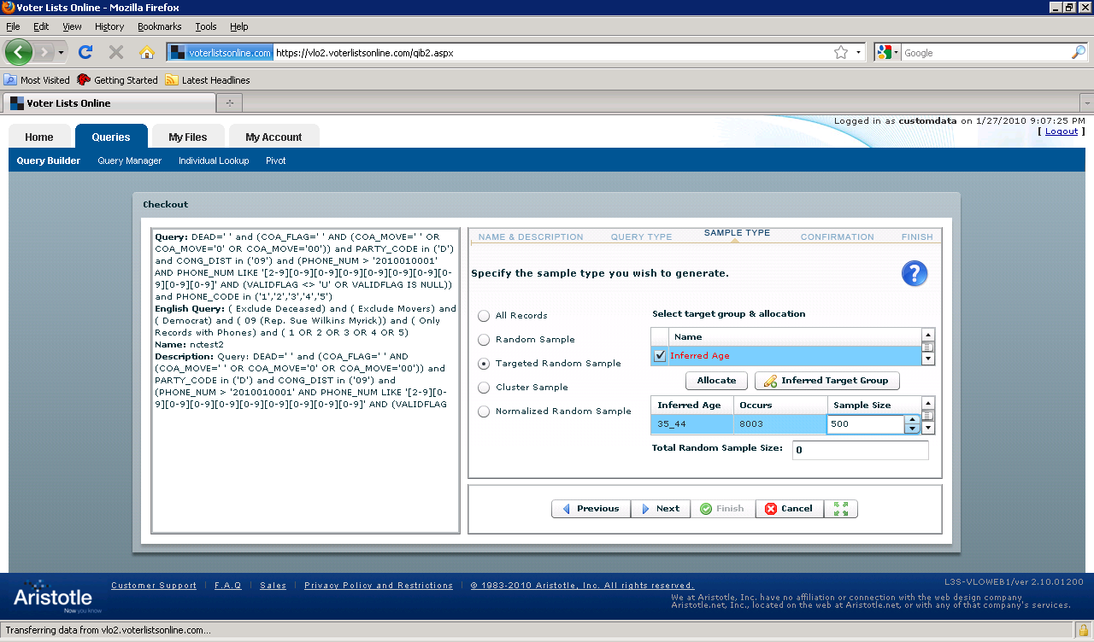

When you are finished, click Next to continue the checkout process.

A second example of how one might choose to use the Inferred Target Group is targeting by Party Code. Suppose you want your sample to consist of a certain number of Republicans, a certain number of Democrats, and a certain number of Independent/Unaffiliated voters whose party codes include the values N, U, I, and O. In this case you would set up an inferred target group based on Party Code as shown below:
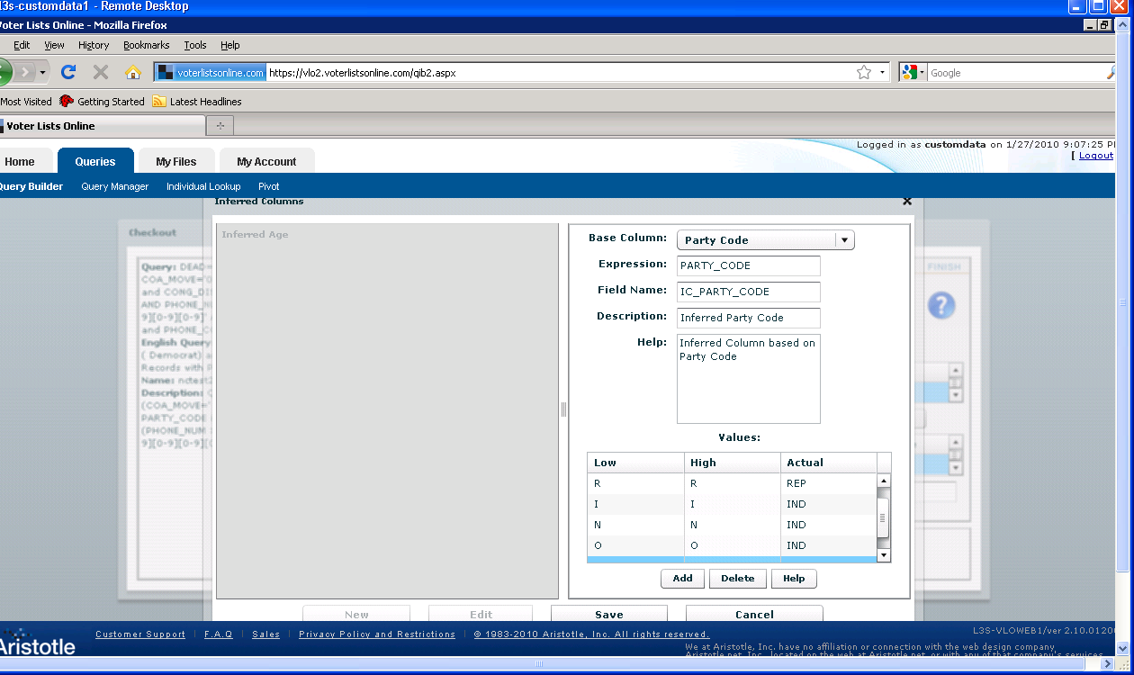

Note that to specify individual values all you need to do is enter the same value in both the Low and High column. Additionally, you can specify multiple non-contiguous values as belonging to the same grouping by specifying the same name for each value in the Actual column. For example, in the above screen shot the values N, I, O and U are all grouped as “IND”.

After your inferred target group is created, you can select it from the list of fields and allocate your sample accordingly:

